  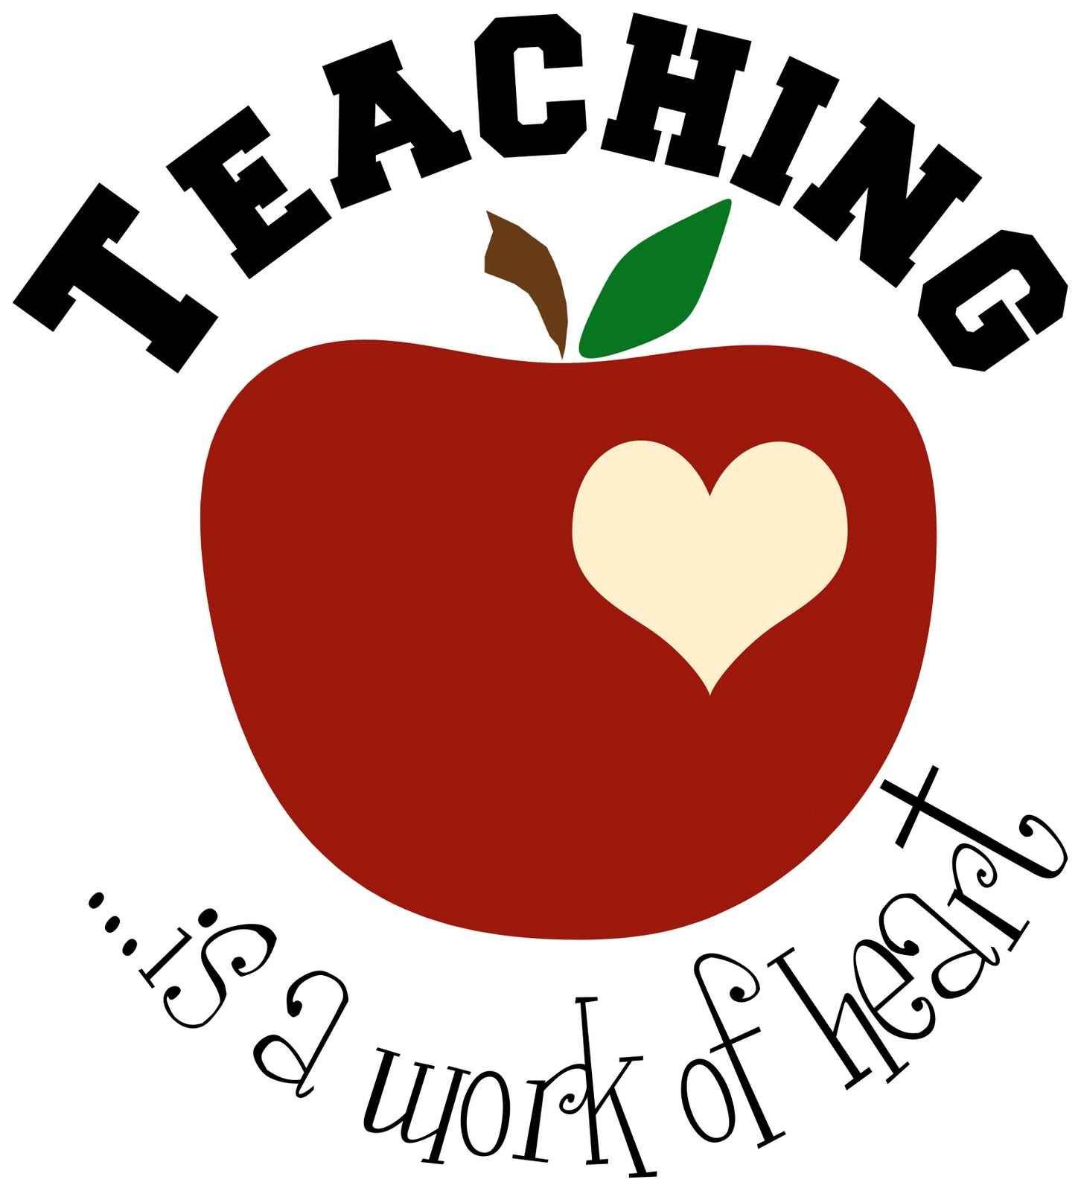
    - saturday, February 29, 2020 9:00am-1:00pm
    - Ridgeveiw High school sky box room
    - 4555 sw elkhorn road
    - REDMOND, or
  OEA Classroom management & de-Escalation strategies Workshop
  BEHAVIOR MANAGEMENT: Learn strategies for setting up a positive system for behavior management that will allow you to maintain high expectations for all students in order to create a safe, respectful and engaging environment in your classroom.
  DE-ESCALATION STRATAGIES: Learn how to prevent a crisis before it even happens in your classroom. Designed by members of OEA’s Special Education Task Force, this session will guide participants through evidence-based practices to de-escalate conflicts and behavior to maintain a positive learning environment for all students. Participants will learn and practice strategies they can apply in their classrooms immediately. All educators -- ESPs, early childhood, K-12, and community college faculty -- who work directly with students of any age are encouraged to attend this session.
  Presented by:
  Leah Starkovich Professional Practice Organizer
  OEA Center for Great Public Schools
  __________________
  Reserve your space today!
  To Register
  http://bit.ly/2MxBNC1
  Offered to OEA Members Only
  Registration Deadline:
  February 24, 2020
  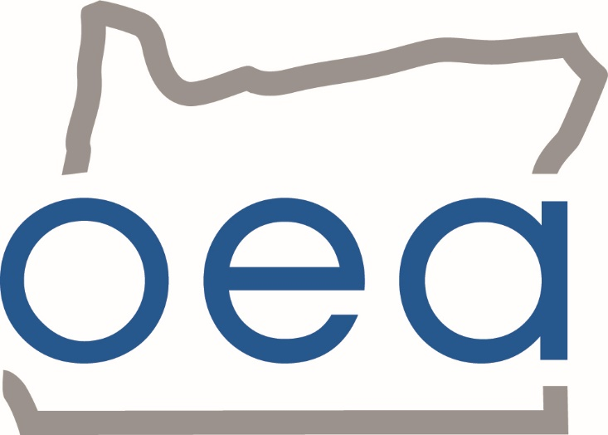
  Oregon Education Association
  2352 SW Glacier Place
  Redmond, Oregon 97756

